Project / Subproject  IDA/EINRC framework 501998  Specific Agreement-7/EIONET | Authors  TietoEnator Corporation | Date issued / Version  16 November 2004/1.0 | User Guide
Client  European Commission  DG Environment / B 1 | Info  The user manual for working with the web interface of Help Admin Tool (HAT) |  | Reference / Page  0000.doc  / 1 of 9

EUROPEAN COMMISSION

ENVIRONMENT DIRECTORATE-GENERAL

IDA-Programme -Framework Contract No 501 998 - 7th Specific Agreement

Einrc - Eionet

User Guide
Help Admin Tool (HAT)


Modification history
Date | Version | Author | Reason for modification
16.11.2004 | 0.1 | J.Heinlaid | Creation of this document

APPROVAL PROCEDURE
Reviewer | Version | Start  Date | Finish  Date | Required modification/Approval/Comments
Framework mgr | 01 | 17.11.04 | 03.12.04 | Approved
Proj. Leader | 01 | 17.11.04 |  | 9.12.2004 Approved after incorporating comments
CMT review
Commission/Project Officer's Approval

Table of Contents

1 Basic concept and terms 4
2 How you can access HAT 5
3 Selecting a target application to work with 5
4 Working with target application screens 6
4.1 Browsing screens and defining new screens 6
4.2 Deleting existing screens 6
5 Working with target application areas 7
5.1 Browsing areas and defining new areas 7
5.2 Deleting existing areas 7
5.3 Editing the content of an area 8

Basic concept and terms
HAT enables to remotely control the contents of certain text areas on the user pages/views of different Reportnet applications. In more formal terms – HAT is web-interfaced client application for managing the dynamical online help of Reportnet applications. This means that from the HAT’s point of view, all the online help text displayed in Reportnet applications is considered by HAT as certain text areas on tge pages of these applications (which it is indeed).
In order to operate, HAT requires the installation of the Reportnet integration framework (AIT – Application Intergation tool) and the Dynamical Online Help (DynOHelp) library and also two special tables in the application’s database. For more details on these requirements and how to install and configure HAT & DynOHelp, see the document at
http://nmc.eionet.eu.int:8980/Members/irc/eionet-nmc/einrc/library?l=/einrc_sa7_2004/dd/dynohelp_hatdoc/_EN_1.3_&a=d
The applications whose online help the HAT is configured to work with, are called target applications. Each user page or user view in the target application is called a screen. Every screen consists of areas. The idea of HAT is that the content of areas is editable via the HAT’s user interface. Since the screens and areas are written in HTML, the HAT literally enables to dynamically control the HTML code of certain screens and areas that the target application developers have selected to be controllable by HAT.
The functionality of HAT enables to perform the following simple operations:
- define new screens
- define new areas
- edit the content of areas
- delete selected areas (if they have been in use, the deletion must be agreed with the target application’s developer(s))
- delete selected screens ((if they have been in use, the deletion must be agreed with the target application’s developer(s))

NB! The following important points must be kept in mind:
- The IDs of defined screens and areas must match the IDs used by the developers of target applications. So in that sense they need to be agreed between the HAT user and target application developer.
- An area’s content has to be valid HTML! It can be simple text or it can have mark-up tags, but in the latter case they have to be HTML tags, valid and correctly used.

How you can access HAT
EEA’s Help Admin Tool is accessible at http://helpadmin.eionet.eu.int/main. The opening page is available for everyone and lists the applications that the HAT has been configured to work with. See a snapshot on figure 1 below.
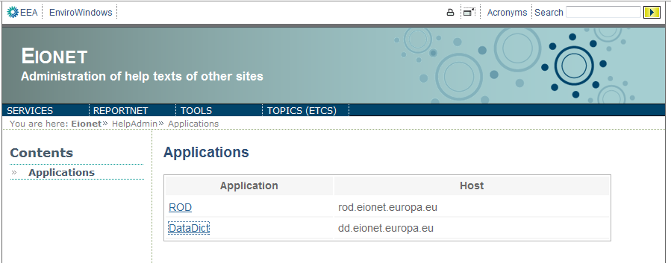
Figure 1. The opening page

Selecting a target application to work with
The above-presented opening page of HAT lists the target application it has been configured to work with. You can only work with one target application at a time, and so you have to select that application by clicking it in the list. As a result, HAT opens a small popup window where you can log onto the application you selected.
Use your EIONET account to log onto a target application. If your account has permissions to edit the target application’s online help text, you will be logged onto the application. Otherwise you will receive an error message. The permissions you must receibe from the owners and/or developers of the target application.
If have successfully logged onto the desired target application, HAT immediately lists all the application’s screens where the help areas are editable by HAT. Next time you click on this application in the applications list, and your session has not expired, you will be prompted with the list of screens right away. Otherwise (i.e. if the session has expired) you will have to log in again. So when working with an application and you receive an error suggesting that the session might be expired, go back to applications list (using the grey button on the left pane) and click your target application again.
If you want to log out from your working application, click the corresponding link on the top right of applications list. If you don’t see this link, it means your session has expired or you have already logged out.

Working with target application screens

Browsing screens and defining new screens
As it was said above, after you have successfully logged into a target application, the HAT lists all the editable screens in that application (see snapshot in figure 2). If no screens have yet been defined, the list of screens is empty. But it enables you to create new screens by clicking Create new. This will lead you to the page that enables to define 2 attributes for your new screen:
- ID
- description

ID is used for the unique identification both by the HAT users and the target application developers (see the important points in chapter 1). The ID can contain white space. If possible, the ID should be chosen so that the essence of the screen is as easily guessable from the ID as possible. The Description is a free text that describes the screen’s location, purpose and contents. Choose it so that by reading it, one can easily understand which part of the application you are talking about. Press Create to submit your inputs.
The Reload button in the list of screens reloads all the screens and areas from the application you’re working with, in case somebody else might have edited them or they become cached for some reason. Use this button, if you’re not sure if you have the latest screens and areas.

Deleting existing screens
To delete existing screens, use the checkboxes and Remove selected button on the screens list. Note that deleting a screen also deletes all its areas!
NB! Please be aware that if you want to delete screens that are being in use by the target application, it must be agreed with the latter’s developer(s).
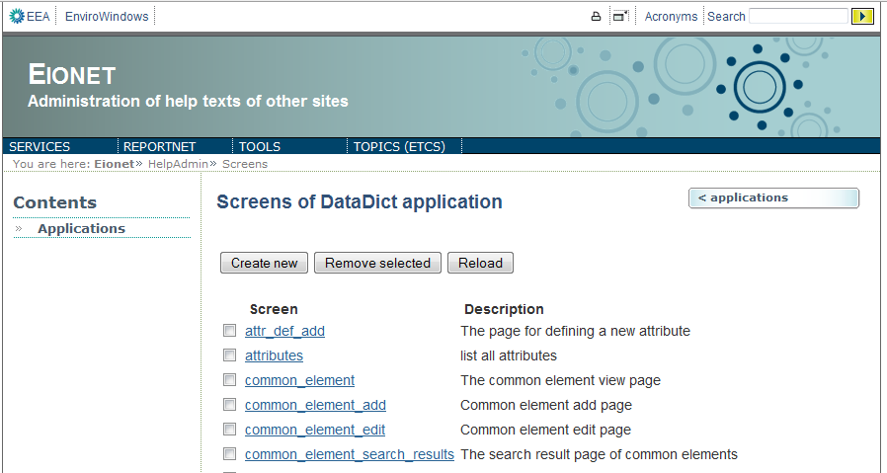
Figure 2. The list of target application screens

Working with target application areas

Browsing areas and defining new areas
When you click on a screen in the target application screens list, you will be taken to the list of areas within that screen (see snapshot on figure 3). If no areas have yet been defined, the list is empty. You can create new areas by clicking Create new. This will take you to the page that enables to define 2 attributes for your new area:
- ID
- description

The area’s ID is used for the unique identification both by the HAT users and the target application developers (see the important points in chapter 1). The ID can contain white space. If possible, the ID should be chosen so that the essence of the area is as easily guessable from the ID as possible. The Description is a free text that describes the area’s location, purpose and contents. Choose it so that by reading it, one can easily understand which part of the screen you are talking about. Press Create to submit your inputs.

Deleting existing areas
To delete existing areas, use the checkboxes and Remove selected button on the areas list.
NB! Please be aware that if you want to delete areas that are being in use by the target application, it must be agreed with the latter’s developer(s).

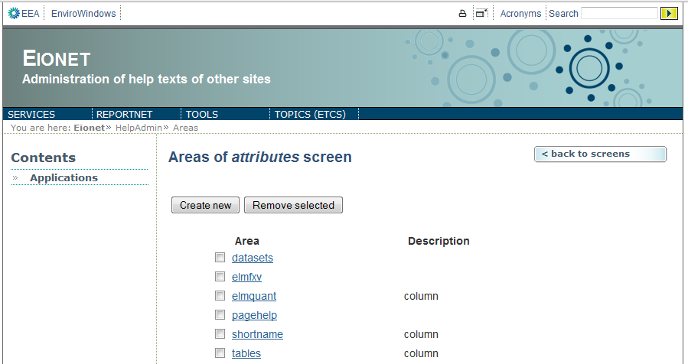

Figure 3. List of areas of a selected screen

Editing the content of an area
As it was mentioned in the 1st chapter, help text of a target application is treated by HAT as nothing more than a certain HTML-coded area in a certain HTML-coded screen or user page or user view in the target application’s web interface. Thus HAT is all about editing the content of the target application areas that have been made editable for HAT.
To edit an area’s HTML content, click the area in the list of areas (see snapshot above). As a result, you will be taken to the HAT’s most important page- the one where you can edit the selected area’s HTML content that will be displayed on the user page/view of the target application.
Despite being an important page, its look and usage is extremely trivial (see the snapshot on figure 4). It has a huge text area where you enter the HTML content, and the Save button for submitting what you’ve entered. There’s also a couple of text inputs for specifying the width and length (i.e. height) of the popup where the given HTML content will be displayed. However, these are relevant only when the given area is displayed as a popup indeed! This has to be agreed with the target application developers. The default values for these inputs are 400 and 400 in units that, once again, have to be agreed with the target application developers.
You submit your inputs by pressing Save. As a result, HAT sends your inputs to the target application and reloads the page with these new inputs. If you are not sure if it went through, go back to the areas list and come back to the area’s content edit view.
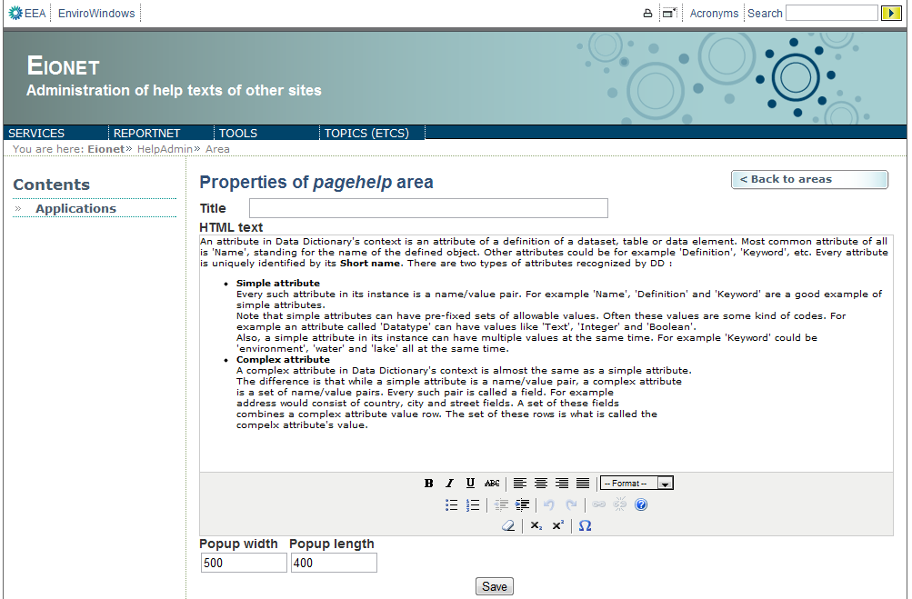
Figure 4. Editing an area’s HTML content

